FINAL REVIEW - REFERENCES
Build Track - Real Estate House Building Inventory and Progress Tracker
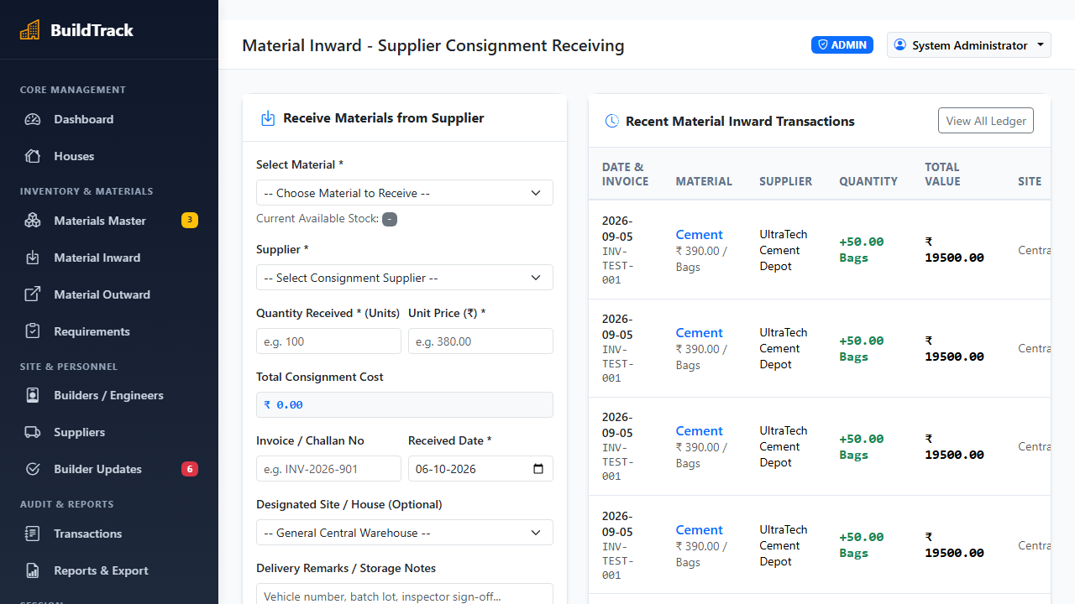
Illustrative Screenshot: BuildTrack real estate construction material dispatch, inward delivery challan verification, and inventory tracking interface.
References:
[1] Pallets Projects, "Flask Web Development Framework Reference Documentation," flask.palletsprojects.com, https://flask.palletsprojects.com/en/3.0.x/, accessed Oct. 2026.
[2] Oracle Corporation, "MySQL 8.0 Reference Manual: InnoDB Storage Engine, Concurrency Control, and Row Locking," dev.mysql.com, https://dev.mysql.com/doc/refman/8.0/en/innodb-locking.html, accessed Oct. 2026.
[3] Python Software Foundation, "Python 3.12 Language and Standard Library Reference Documentation (Decimal Fixed-Point Module)," python.org, https://docs.python.org/3.12/library/decimal.html, accessed Oct. 2026.
[4] Pallets Projects, "Werkzeug WSGI Utility and Cryptographic Password Hashing (Scrypt/PBKDF2) Specification," werkzeug.palletsprojects.com, https://werkzeug.palletsprojects.com/en/3.0.x/utils/#password-hashing, accessed Oct. 2026.
[5] World Wide Web Consortium (W3C), "Media Capture and Streams (HTML5 getUserMedia API) Specification," w3.org, https://www.w3.org/TR/mediacapture-streams/, accessed Oct. 2026.
[6] Mark Otto and Jacob Thornton, "Bootstrap 5.3 Responsive Front-End Framework Documentation and Grid Architecture," getbootstrap.com, https://getbootstrap.com/docs/5.3/, accessed Oct. 2026.
[7] Oracle Corporation, "MySQL Connector/Python Developer Guide for Connection Pooling and Prepared Statements," dev.mysql.com, https://dev.mysql.com/doc/connector-python/en/connector-python-connection-pooling.html, accessed Oct. 2026.
[8] Mozilla Developer Network (MDN) Contributors, "HTML5 Canvas API, DataTransfer, and Blob File Binding Interfaces for In-Browser Image Processing," developer.mozilla.org, https://developer.mozilla.org/en-US/docs/Web/API/Canvas_API, accessed Oct. 2026.
[9] Pallets Projects, "Jinja2 Template Engine Documentation and Server-Side XSS Autoescaping Security," jinja.palletsprojects.com, https://jinja.palletsprojects.com/en/3.1.x/, accessed Oct. 2026.
[10] ReportLab Inc., "ReportLab Open Source PDF Generation Architecture and Reporting Engine Reference Guide," reportlab.com, https://docs.reportlab.com/, accessed Oct. 2026.

